Atwood's Machine Lab

Data Table

Part I: Constant Total Mass
Trial | m₁ (kg) | m₂ (kg) | Acceleration (m/s²) | Δm (kg) | (Δm)·9.8 Fnet (N) | m_T (kg) | Expected a (m/s²) (Ext. 2)
1 | 0.105 | 0.095 | 0.3918 | 0.010 | 0.098 | 0.200 | 0.490
2 | 0.110 | 0.090 | 0.8453 | 0.020 | 0.196 | 0.200 | 0.980
3 | 0.115 | 0.085 | 1.276 | 0.030 | 0.294 | 0.200 | 1.470
4 | 0.120 | 0.080 | 1.754 | 0.040 | 0.392 | 0.200 | 1.960
5 | 0.125 | 0.075 | 2.221 | 0.050 | 0.490 | 0.200 | 2.450

Part II: Constant Mass Difference
Trial | m₁ (kg) | m₂ (kg) | Acceleration (m/s²) | Δm (kg) | (Δm)·9.8 Fnet (N) | m_T (kg) | Expected a (m/s²) (Ext. 2)
1 | 0.070 | 0.050 | 1.437 | 0.020 | 0.196 | 0.120 | 1.633
2 | 0.090 | 0.070 | 1.083 | 0.020 | 0.196 | 0.160 | 1.225
3 | 0.110 | 0.090 | 0.8632 | 0.020 | 0.196 | 0.200 | 0.980
4 | 0.130 | 0.110 | 0.7160 | 0.020 | 0.196 | 0.240 | 0.817
5 | 0.150 | 0.130 | 0.5907 | 0.020 | 0.196 | 0.280 | 0.700

Analysis

3.

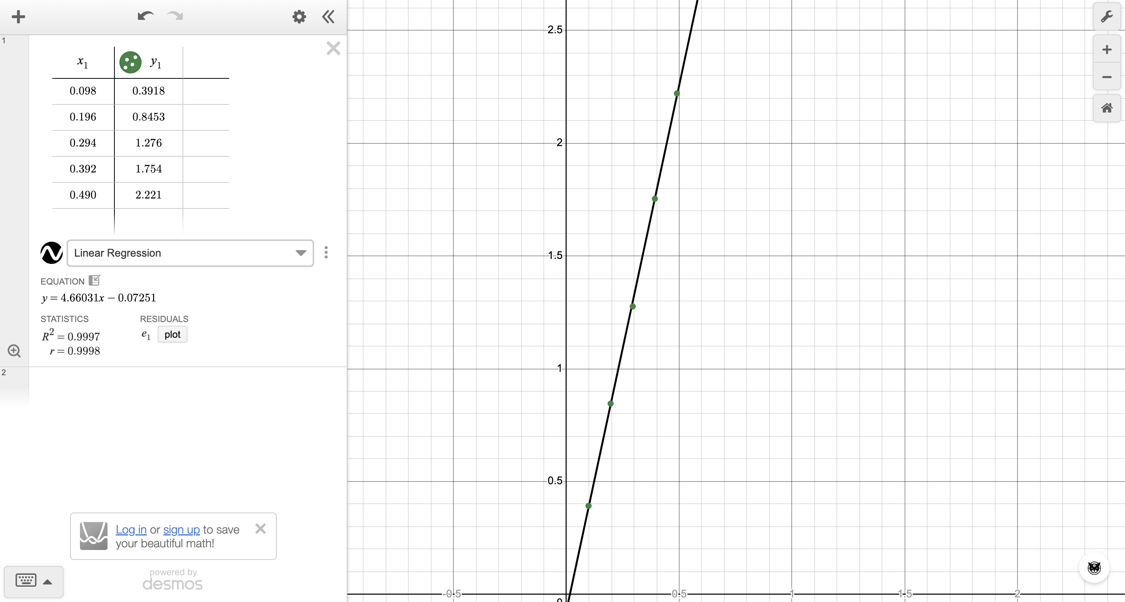

My best fit line is a = 4.66031·F_net − 0.07251, and R^2 = 0.9997. The points make a straight line that goes almost through zero. Therefore acceleration is directly proportional to the net force ( 9.8 times delta mass). So if I double Δm, the acceleration about doubles.

What the slope means: F = ma, so a = F/m. This matches y = mx + b because a is on the y-axis and F is on the x-axis. Therefore the slope = 1 / m

1 / slope = m = 1 / 4.66031 = 0.215 kg

4.

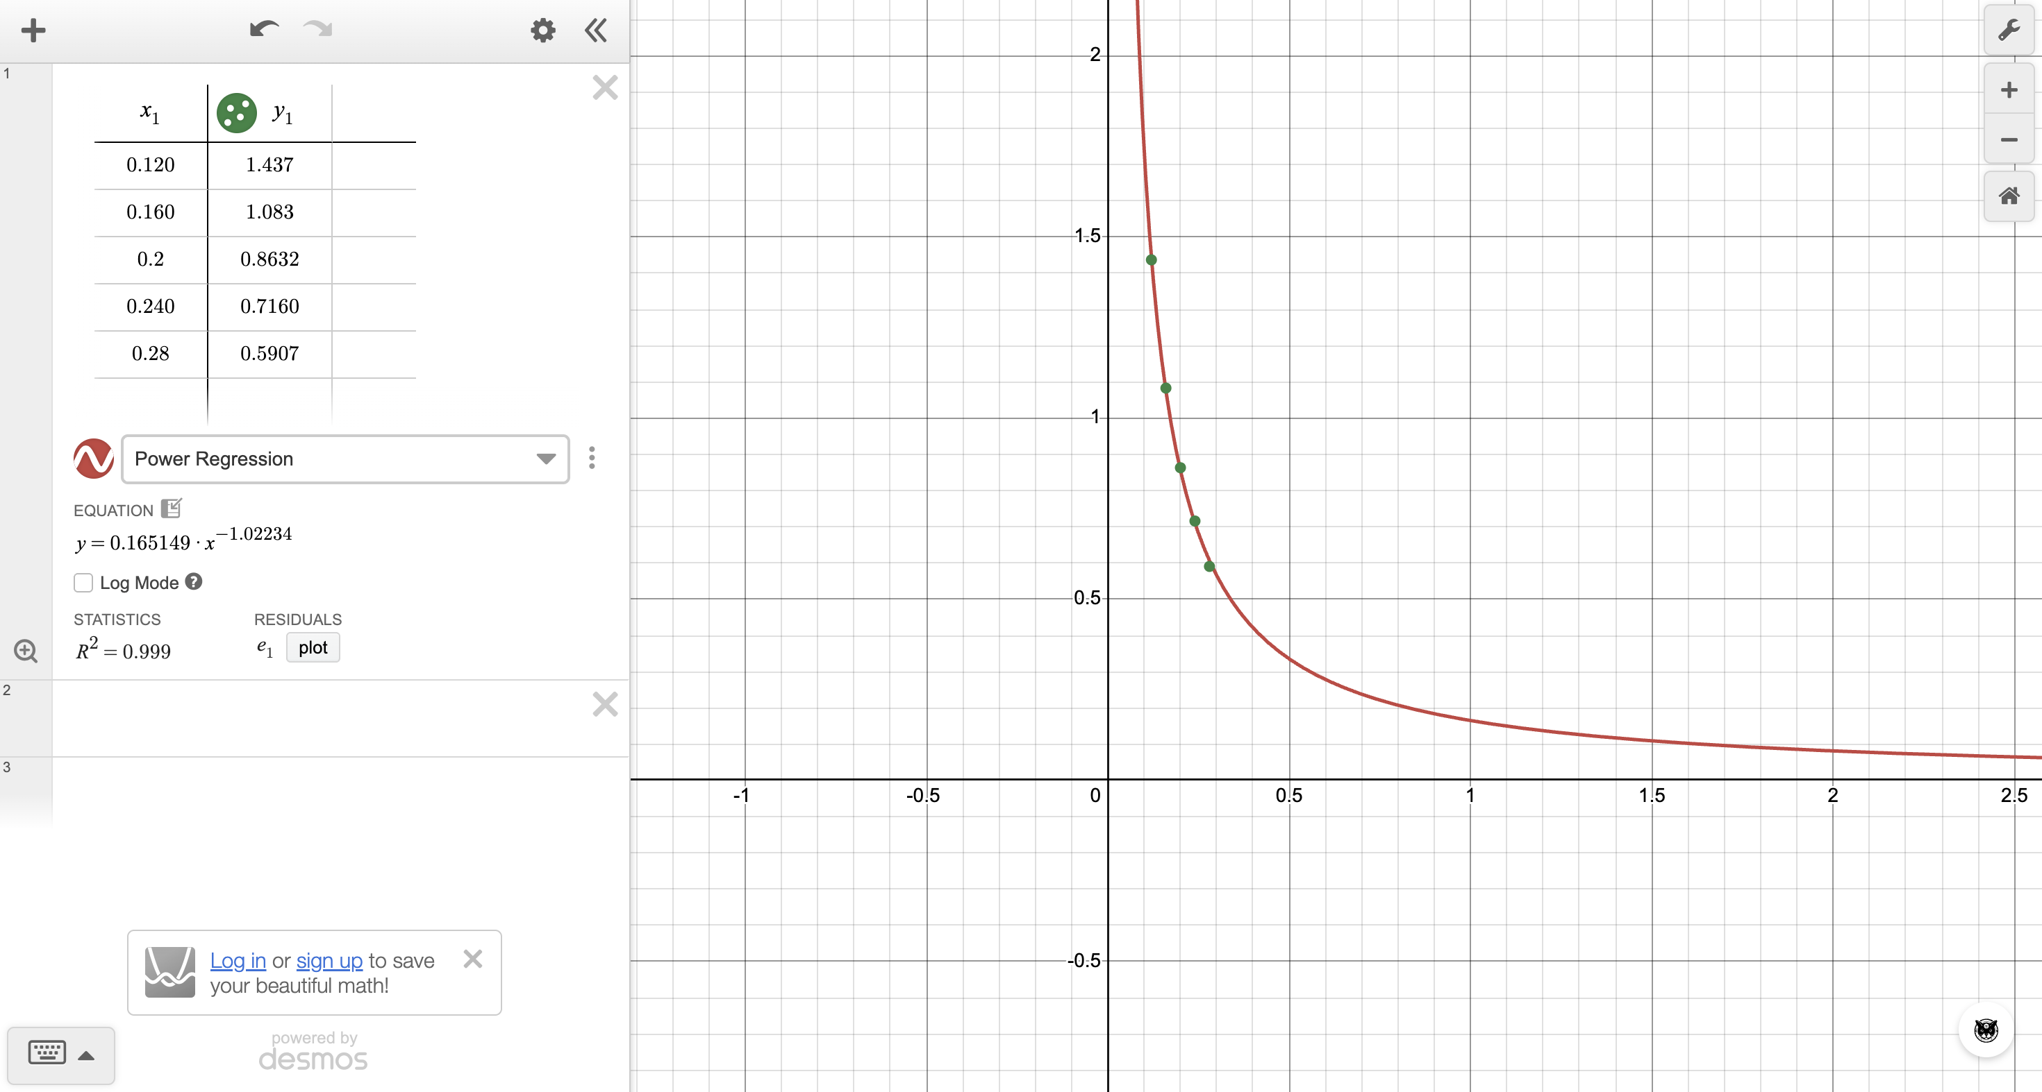

My power fit is a = 0.165149·m_T^(−1.02234), and R^2= 0.999. The exponent is about −1, so a ≈ k / m_T. Therefore acceleration is inversely proportional to total mass. So when the total mass goes up, the acceleration goes down.

5. From #3, a ∝ 9.8(delta m). From #4, a ∝ 1 / m_T. Putting both together:

a = delta m(9.8) / m_T

This makes sense because delta m·g is the net force and m_T is the mass being moved. So it is really just a = F_net / m, which is Newton's second law.

Extensions

1. Free-body diagrams (m₁ is the heavier mass):

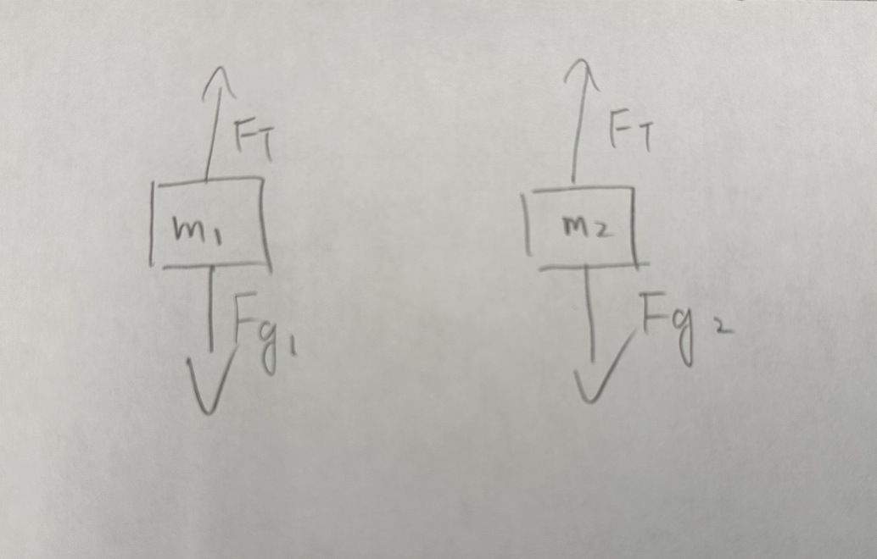

Each mass has two forces: gravity F_g pulling down and tension F_T pulling up. The tension is the same on both sides. m₁ goes down and m₂ goes up, so I call that direction positive for each one.

m₁: F_g1 − F_T = m₁a

m₁g − F_T = m₁a

m₂: F_T − F_g2 = m₂a

F_T − m₂g = m₂a

Add the two equations. F_T cancels out:

m₁g − m₂g = m₁a + m₂a

(m₁ − m₂)g = (m₁ + m₂)a

a = (m₁ − m₂)g / (m₁ + m₂)

This is the same as my answer to Analysis #5 (a = delta m (9.8) / m_T), and it also shows that the constant is g.

2. Expected a = (Δm)(9.8) / m_T. All the expected values are in the last column of the data table.

Example (Part I, trial 3): expected a = (0.030)(9.8) / 0.200 = 1.47 m/s²

Measured a = 1.276 m/s², which is lower

Every one of my measured values is lower than expected. They are low because the formula assumes a perfect pulley with no rolling friction and no mass, and our pulley isn't perfect. Friction takes away some of the net force. The pulley has mass, so some force goes into spinning it. Therefore less force is left to speed up the masses, so the acceleration comes out lower.

3. I used my Part I trial 1 masses: m₁ = 0.105 kg (heavier side), m₂ = 0.095 kg (lighter side).

Holding the string: nothing moves, so each side of the string just holds up its own mass.

Heavier side: F_T = m₁g = (0.105)(9.8) = 1.029 N

Lighter side: F_T = m₂g = (0.095)(9.8) = 0.931 N

The two sides are different because my finger holds the string and makes up the difference.

After letting go: the string moves freely, so the tension becomes the same on both sides.

F_T = 2m₁m₂g / (m₁ + m₂) = 2(0.105)(0.095)(9.8) / 0.200 = 0.978 N

yes, the tension changes. The heavier side drops from 1.029 N to 0.978 N, and the lighter side goes up from 0.931 N to 0.978 N. Because the tension on the heavy side is now less than its weight, it speeds up going down. Because the tension on the light side is now more than its weight, it speeds up going up.

4. The force sensor reads the tension on both sides added together.

Held still: F = m₁g + m₂g = 1.029 + 0.931 = 1.960 N

Released: F = 2F_T = 2 × 0.97755 = 1.955 N

So the reading goes down a little after I let go. This is because the heavy mass speeds up going down and the light mass speeds up going up, so overall the system is speeding up downward. Therefore the pulley doesn't have to hold up the full weight anymore.

